**Edge Detection**

To set this up is a rather complex process. The first step in this is to pick the right piperline, for this we’ll pick URP.

Then you have to make sure to install the shader graph package

Now from here you’ll have to find the “Universal Render Pipeline Asset_Render” and add a render feature and call it “DepthNormals”

Note this should be the preexisting “Universal Render Pipeline Asset_Render” not the one included in the package

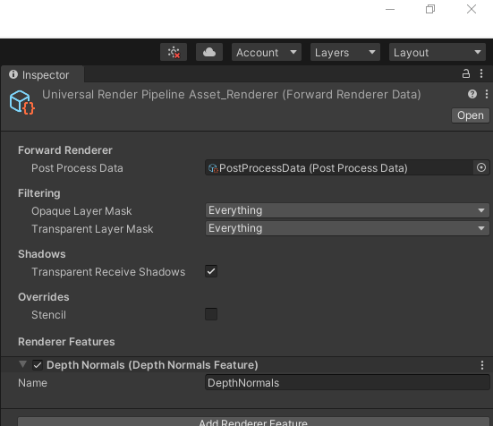

From here you add a new material and set the shader as shadergraph/simpleOutLines

There are a few main variables to keep in mind these are

OutLinethickness:a good range is 0.001-0.003

OutlineAcuteStartDot: 0.9

OutLineNomralStrength: 128